

**A Tale of Two Cycles**

Speech given by

Sir John Gieve, Deputy Governor, Bank of England 19 June 2008

1

All speeches are available online at [www.bankofengland.co.uk/publications/Pages/speeches/default.aspx](http://www.bankofengland.co.uk/publications/Pages/speeches/default.aspx)

# Introduction

Ladies and Gentlemen, it is a great pleasure to be here this evening in what has been a busy week for the Bank, with the open letter to the Chancellor in response to the news on Tuesday that CPI inflation rose to 3.3% in May, the latest MPC minutes, and the Chancellor’s announcement last night of an enhanced role for the Bank on financial stability. Things have certainly changed in the year since your chief executive, James Ramsbotham, asked me to speak here this evening.

The Bank's links with this region go back to 1828 when, in response to a crisis of confidence (this one over locally issued bank notes), we opened a branch in Newcastle. The move was not well received. The Newcastle Chamber of Commerce, wrote to the Directors of the Bank of England, saying "in the absence of any avowed motive for the establishment of a Branch of the Bank of England, in Newcastle, [we] see no prospect of good from such an establishment. [We] most earnestly

recommend to the Directors of the Bank of England to re-consider the policy of the measure they are about to adopt and to abstain from trying such an experiment on a system of banking, the advantages of which are so generally felt and admitted."

I am pleased that our current Agents, David Buffham and Will Dowson receive a warmer welcome from Chamber members and others as they travel around the region. Our agents are the eyes and ears of the Bank. They make sure that we take account not just of the economic statistics, which at best tell us what has just happened (and all too frequently fail to do that), but also know what businessmen and women are saying about their own outlook and plans. The Monetary Policy Committee receives a report from each region each month and I can assure you it always receives a lot of attention. All the members of the Committee also get out to meet businesses themselves and that is why I am here in the North East for two days.

The main subject of my speech tonight is the wider economy, and in particular the tale of two cycles – the downswing of the financial cycle and the upswing in the commodity price cycle.

# The economic environment in context

But first, it is important to recognise that the last ten years have been a period of remarkable stability for the UK’s economy. It has certainly been the most stable and successful period for the economy in my lifetime. 1

When the MPC was set up, Charlie Bean – then a leading academic, soon to be my fellow Deputy Governor – estimated that inflation would be away from the target by more than 1 percentage point in nearly 5 months of every year. Yet this week the Governor’s open letter to the Chancellor to explain why inflation last month had deviated by more than a percentage point from the target was only the second written in over 10 years.

And taking the past decade as a whole, this stability of inflation has not come at a cost to growth – quite the opposite in fact. Output growth has been high both relative to the rates achieved on average over the preceding 30 years and in comparison with our European neighbours. It also has been remarkably stable.2

Of course that stability at the macro level disguises some big changes in the structure of the economy. Indeed it has provided a platform for change. The North East for example is now much more diverse than it was and less reliant on a few large industries. And, overall more people are employed in the region: the number employed in the North East has risen by more than 100,000 in the past ten years. And export growth remains relatively buoyant.

1 Indeed work done at the Bank suggests that in terms of inflation, it has been the most stable decade in many lifetimes – that is, since the Restoration at least (Benati (2006)).

2 It has only deviated by more than 1 percentage point from that average on 4 occasions. To put this in

context, in the preceding 3 decades stretching back to the 1960s, annual GDP growth deviated from its 10 year average by more than 1 percentage point about half of the time (about 20 quarters in each 10 year period).

In contrast to this picture of stability, the preceding 3 decades were scarred by painful recessions where unemployment rose sharply, and inflation fluctuated wildly. In particular, there were three episodes between the mid-1970s and early 1990s, when inflation rose very sharply, and at around the same time output contracted. While there are many in the room that don’t need reminding, I thought I would just give the younger members of the audience a reminder of just how desperate those times were (Chart 1).

In 1975, RPI inflation peaked just shy of a staggering 27% while at the same time output fell. It was this era that entrenched the term “stagflation” in the minds of the public. Inflation fell back sharply over the subsequent year or so, only to rear its head again in 1979-80 – this time peaking at around 22%. Once again output contracted and unemployment rose sharply (Chart 2).

A third and final bout of rising inflation and falling output occurred in the early 1990s, with the unemployment rate once again rising above 10%. On average, inflation in the 1970s was around 13% and 7.5% in the 1980s.

# The UK macroeconomic framework

Why was it that output and inflation were so volatile then and why has economic performance improved so much in the past 10 years? These questions are vital as we face more uncertain times ahead and to ensure that we avoid repeating the mistakes of the past. I would point to three main factors.

There have been changes to the structure of the UK economy that have made it more flexible and adaptable. Labour market reforms enacted over the past twenty-five years have led to a more flexible workforce. Unemployment has fallen without generating unsustainable growth in wages, and hence inflation. And in recent years the role of migrant labour has been important in easing the bottlenecks and skill shortages in what was otherwise an undoubtedly tight labour market. Firms have been able to adjust and adapt to events more quickly and that has produced less volatility in

output, employment and inflation for the economy as a whole. With economic growth expected to slow over the coming year pressures in the labour market are likely to ease, reducing the demand for migrant labour, and possibly beginning to reverse recent strong inflows.

A second fundamental change has been to the monetary policy framework. The experience of those three recessions and bursts of inflation has led to a settled consensus that monetary policy should be directed at controlling inflation and that there is no long-run trade off between inflation and output growth. This consensus has been embedded by transferring interest rate decisions to an independent Bank of England, with a clearly defined inflation target of 2% measured by annual CPI inflation. That has helped build confidence that if inflation does move away from target, we on the Monetary Policy Committee will act to ensure that it returns to target in the medium term. That confidence should ensure that employers and employees are less likely to adjust their prices and wages to a surprise movement in inflation. In other words, their expectation of inflation in the medium-term remains low, stable and anchored at the target. And that has helped to contribute not only to the stability of inflation, but output as well.

Reforms to both the labour market and monetary policy have undoubtedly played an important role in the reduction in output volatility and emergence of a stable, low inflation environment. But there was a third factor at play that was probably also quite fundamental. Over the first decade of the MPC the economic cycles in the rest of the world were generally moderate, although not without excitement. And there is good evidence to suggest that the integration of emerging economies, such as China, into the global economy was beneficial to countries like the UK. The share of Chinese goods in total UK goods imports has almost tripled in money terms over the past fifteen years to around 8 per cent, and it’s likely that much of the content of imports from elsewhere originated in China. This rising share of Chinese imports has reduced manufactured imported goods prices relative to other prices and wages.

Consumer goods price inflation hovered around zero for most of the last ten years, until the recent rise in oil prices**.** As a result, the purchasing power of UK consumers has risen with higher real wages achieved without any cost to employers. In other words, for a period the beneficial tailwind allowed the economy to run at a higher level of activity than would otherwise have been the case, without generating additional inflationary pressures

But the economic environment overseas has taken a turn for the worse. In many ways it is a tale of two cycles.

# The financial cycle

The first cycle has been in the financial sector in the West. A banking cycle is not a new phenomenon but the scale of the expansion of cheap credit for some years and speed of the downswing in the last year has been exceptional.

It started in the US with a real downturn in the housing market and rising default rates on sub-prime mortgages in particular. That led to a freeze in the structured credit markets built on those loans as investors lost confidence in the credit ratings they depend on.

In finance at least, it is still true that when America sneezes the rest of the world catches a cold and the sub-prime crisis swiftly spread to financial institutions across the world. They became uncertain about the value of the financial positions they held, let alone what their counterparties held. This led to a wider loss of confidence in banks, the hoarding of cash and illiquidity in many financial markets which is still not over.

As financial institutions all around the world have struggled to shrink their balance sheets in the face of this storm, there has been a pronounced tightening in the supply of credit. The number of loan approvals for house purchases fell to a new low in April to – on some indicators – its lowest level in over thirty years (Chart 3).

In the past, the swings in the UK economy have been home grown. Credit squeezes have typically resulted from rising domestic arrears and defaults, driven by economic downturns at home. This time the sequence has been reversed. The broadest measures of economic activity have continued to grow: quarterly GDP growth in the latest data for 2008Q1 was 0.4% and employment has continued to rise. The level of defaults on corporate and personal loans has been low. So the squeeze on new lending has preceded rather than followed the slowdown in the UK. The judgement we have to make is how far that tightening will restrain the domestic economy in future.

There is no doubt it is having a material effect already (Chart 4). This is most obvious in the housing market, where prices have fallen by around 7% since their peak, and have further to fall. The drop in transactions and turnover is rippling through the housebuilding industry, estate agencies and mortgage brokers. Of course a fall in house prices benefits buyers just as it hurts sellers so there is no necessary link to wider consumption. But the belief that in housing you could have your cake and eat it – that is your house would not just provide a place to live but would also provide an assured capital gain – has become widespread and the shock to expectations appears to be having a wider impact on confidence. There are also signs in some of the more timely survey indicators of consumer spending that weakness is spreading there too.

If nothing else were going on, the MPC would expect this prospective weakness in overall demand to put downward pressure on inflation in the medium term and that would be pointing to further rate cuts.

# The commodity price cycle

However, there is something else going on! Because if the US still drives the financial cycle, it has become less dominant in the world economy. According to the IMF, emerging and developing countries together generated around 70% of world

growth in 2007, with China alone generating around 25%. And the world economy has been and still is growing strongly. That is what has been driving the rise in oil and commodity prices. For example, since the start of 2005, China has accounted for almost all of the increase in world demand for key metals such as aluminium, copper and zinc. And since 2000, around one-third of the increase in world demand for oil has emanated from China.

Between 1997 and 2004 commodity prices were largely stable. However, since the end of 2004, sterling non-oil commodity prices have doubled, while sterling oil prices have more than trebled. And half of that rise has occurred in the last 9 months.

The strength of demand for commodities in emerging markets has not been matched by supply. In both the oil and metals sector, new capacity can take many years to come on stream. And in the agricultural sector, output has been affected by adverse weather conditions in North America, Europe and Australia.

As of yesterday, oil was trading at around $130 per barrel. Relative to the rise in the prices of consumer goods and services, oil prices (in US dollars) are now higher than they were in the 1970s. The rise in oil prices has pushed up on fuel, retail gas and electricity prices. Similarly, the rising cost of agricultural commodities has driven up food prices (Chart 5). Taken together energy and food components can account for

* 1. percentage points of the 1.2 percentage points increase in CPI inflation from 2.1% in December last year to 3.3% in May.

There is no doubt that the emergence of China, India and other Asian economies in recent years is a permanent change in the structure and balance of the world economy. But there are signs too that an element of their recent growth may be cyclical. The growing inflationary pressures and the scale of the booms in investment are typical of economies reaching the top of the cycle. The huge increase in oil and food prices will itself have a dampening effect on consumers in those countries – as it

will in the West. So we may well see the balance of supply and demand shift at some point.

# UK inflation outlook

But the immediate prospect is for rising inflation. As the Governor explained in his open letter to the Chancellor, when the rise in energy prices passes through to consumers, CPI inflation is likely to rise sharply in the second half of the year, to above 4%. There is of course considerable uncertainty around this, and if energy and other import prices rise further, CPI inflation could well go even higher in the short term. That is bound to lead to a downward adjustment to real take-home pay. That cannot be avoided. Indeed, such an adjustment was seen in response to the rise in energy prices in 2004-06. Over that period, nominal wage growth was broadly stable, and there was a relatively smooth adjustment to real wages in response to the rise in energy prices.

A key risk to the outlook is whether a similar, benign adjustment will occur in response to the latest price rises. With inflation having been above target for much of the past three years, and set to rise further in the near term, there is a risk that households and businesses may start to expect CPI inflation to be persistently above 2%. If that happened, and those expectations were built into higher wages and prices, the benign adjustment would not be repeated. So we are closely monitoring developments in inflation expectations. Unfortunately inflation expectations can’t be observed directly. But a number of measures, including household surveys and financial market instruments, can act as a guide (Chart 6).

While all these measures have their drawbacks, most have risen – in some cases markedly – over the past year. It is unclear to what extent these measures contain information about the medium-term – the horizon over which the MPC aim to bring inflation back to target. And it is comforting that other measures – such as money spending remain stable and in line with the average rate of increase since 1997. And

the Committee’s commitment to ensuring inflation returns to the 2% target should give those setting prices and wages some confidence that inflation will be close to target in the future.

# Conclusion

There is no doubt that the current climate is the most challenging the MPC has ever had to face. Balancing the downside risk to demand associated with tighter credit conditions against the inflationary pressures emanating from the rest of the world is an enormous challenge. And the immediate prospect is for a deterioration in both output growth and inflation.

Monetary policy cannot prevent the economy being buffeted by developments in the wider world economy but the experience of the past 10 years has shown that the economy is now more flexible in responding to events. Crucially we now have a credible framework for setting monetary policy to meet the inflation target in the medium term.

Monetary policy cannot prevent the short-run ups and downs of economic cycles. In the current climate, the Committee believes that, if Bank Rate were set to bring inflation back to target too quickly, the result would be unnecessary volatility in output and employment. Instead we are focused on returning CPI inflation to the 2% target in around two years, when the present sharp rises in energy and food prices will have dropped out of the CPI inflation rate. We judge that in order for inflation to return to target it will be necessary for economic growth to slow this year, reducing the pressure on supply capacity of the economy and dampening increases in prices and wages. But the risks to both the upside and downside remain large and the MPC will continue to make its judgement about the appropriate level of Bank Rate month by month.

The next year is not going to be comfortable for anyone and we already hear calls to change the system, the target, and our focus on inflation. But the new framework and

the independence of the Bank was designed for difficult times as well as for plain sailing. I hope we can look to you and other businesses for support in doing what is needed to bring inflation back to target.

# Chart 1: Long-run of GDP and RPI inflation Chart 2: Unemployment rate

Percentage change on a year earlier

30.0

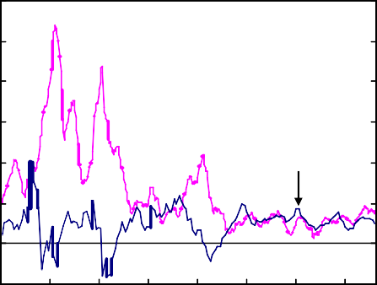

RPI

GDP at

market prices

25.0

20.0

15.0

10.0

5.0

0.0

-5.0

Percentage change on a

year earlier

30.0

25.0

20.0

15.0

10.0

5.0

0.0

-5.0

Per cent

14

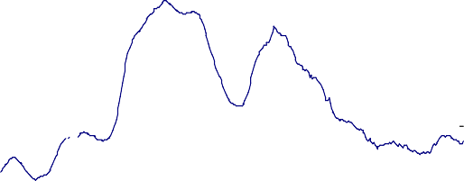

12

10

8

6

4

2

0

1970 1975 1980 1985 1990 1995 2000 2005

1970 1975 1980 1985 1990 1995 2000 2005

* + 1. Labour force survey measure

# Chart 3: Mortgage approvals Chart 4: House prices

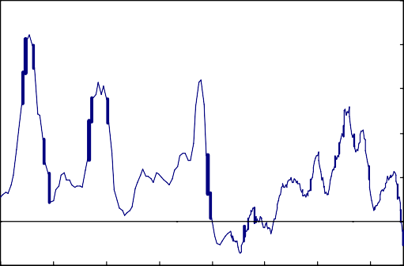Quarterly mortgage approvals/advances as a percent of the stock of ow ner-occupied homes(a)

3.5

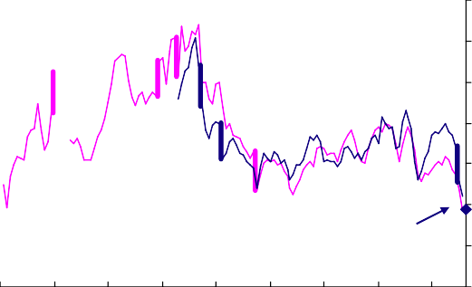

Mortgage approvals

Mortgage advances (CML)(b)

April approvals data at quarterly rate

3.0

2.5

2.0

1.5

Percentage change on a year earlier

50

40

30

20

10

1974 1978 1982 1986 1990 1994 1998 2002 2006

1.0

0.5

0.0

1970 1975 1980 1985 1990

1995 2000 2005

0

-10

Sources: Bank of England, Council of Mortgage Lenders and Department for Communities and Local Government.

1. Lending flows expressed as a percentage of stock of owner- occupied homes.
2. Data prior to 1992 Q2 are based on loans by building societies.

Sources: Bank of England, Halifax and Nationwide.

(a) Average of Halifax and Nationwide measures from 1983 onwards. Prior to that, the Nationwide measure is used.

# Chart 5: Contributions to CPI inflation

Other Utilities Food Petrol Percentage points

4.0

`

3.5

3.0

2.5

2.0

1.5

1.0

0.5

0.0

-0.5

2004 2005 2006 2007 2008

# Chart 6: Change in measures of inflation expectations since August 2007

Number of standard deviations Percentage points

1.8 1.8

Longer-term

Next twelve months

1.6 1.6

1.4 1.4

1.2 1.2

1.0

0.8

1.0

0.8

0.6 0.6

0.4 0.4

0.2

0.0

GfK NOP(a) Bank/Gfk NOP(b) YouGov/

5-year inflation 10-year inflation

YouGov/

0.2

0.0

Citigroup(c)

forward rates(d) forward rates(d) Citigroup (5-10

years)(c)

Left-hand scale Right-hand scale

Sources: Bank of England, Bloomberg, Citigroup, GfK NOP, research carried out by GfK NOP on behalf of the European Commission and YouGov.

1. Net balance expecting prices to increase.
2. Median of respondents' expected change in prices in the shops generally.
3. Median of respondents' expected change in prices of goods and services.
4. Implied instantaneous inflation rates five and ten years ahead based on the difference between the interest rates prevailing on nominal and index-linked government bonds.